Thought Note of Ecommerce website

**1.Header Section:**

* Header Section is devided into section first section include the Logo of website ,search bar and button , Login Button and cart icon
* Logo of the website placed at the top left corner which would be clickable and came at the home page of the website
* Search bar and Button placed at the middle of the header which allow the user to search items name which user want to search in the respective pages
* Login Button and cart section are placed at the top right corner of header which take the user at the respective pages after clicking (i.e..Login Page and Cart pages)
* Section Section of the Header Contains navigation bar and links to the pages and it also contain dropdown the in Men’s and woman section like in women contain (All women’s product ,dress ,pants ,skirt’s), and in men categories contain(All men’s pages , pants, hoddies, shirts) kids and contact pages all the categories of the products are also clickable



**2.Footer Section**

* It contains the products categories same as header and also include copy right section to the end of the footer
* All the items links are clickable and working
* Responsive in Mobile ipad mini



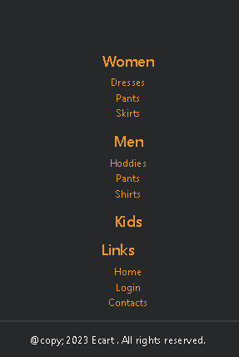

* **Note :**

Header and Footer are common across all the so is include using Dynamic Loading (using js)

**Home Page**

1. **Cover Page**

* It contains the Background image and over that company slogan and and animate text using .js animation which change after time set
* It also Contain two button Buy Now and Sign in which will clickable and redirected to the cart and Login pages

1. **Featured Products Section:**

* Featured Page implemented using slider and placed just above the footer to easy navigation
* I am using owl crousel components as refrences and implanted
* Slider must be responsive In medium screen 2 images and small screen 1 images and in large screen laptops and tablet it shows 5 images

**Card Design included Products**

* Images of the products
* Discription of the products
* Add to cart Button



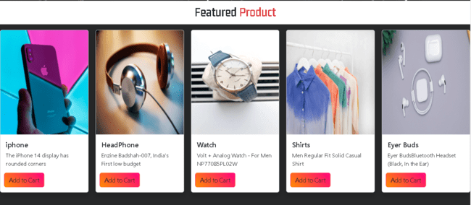

**Products Pages**

* Display Products in a row and col formats like grids in men women kids and all products
* Include subcategories in women and mens also like dress , pants and hoddies shirts and skirts
* Cart display after the hovering on the products
* Kids page are also organised in row col formats like grids

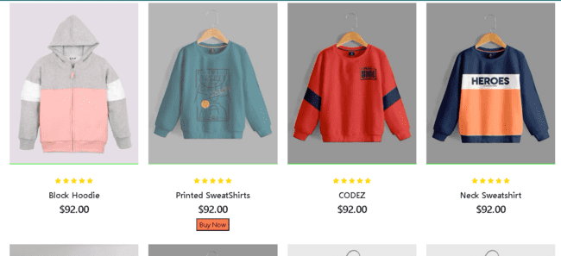

**Contact us Page**

* Designing a professional contact page using 2 column layout
* In the first column display an image that represents the business which identify the brand and purpose
* In the second column placed a contact form using bootstrap component
* Include input for additional information like name , mail and messages
* Used appropriate level and placeholder
* Pages are responsive using row and column using bootstrap

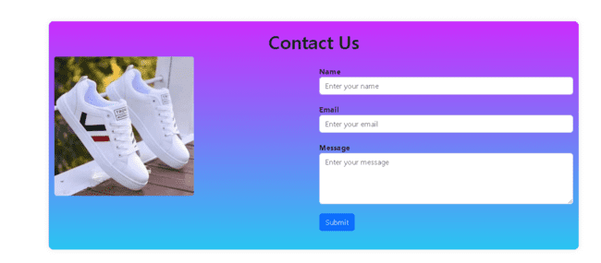

**Login Page:**

**Create a user friendly Login page**

* Include the fields for user like user mail id and password and submit button
* Using bootstrap component pages are responsive in different screen like mobile , ipad and laptops
* Use JavaScript to handle the login check logic after the user submits the form.
* Check if the entered email address and password match specific values (e.g., email: "[admin@admin.com](mailto:admin@admin.com)" and password: "123456")

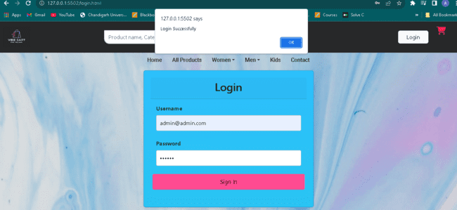

**Cart Page**

* Divide the cart page into two main parts arranged using column of bootstrap like grid
* First part is section for list of item in the cart
* And both section have transition property
* Item Listing Grid:
  + Inside the first part, create a 3-column grid for each item.
  + Column 1: Display the product's image.
  + Column 2: List the product's name and price, and include a delete button (using Font Awesome's trash icon) to remove the product from the cart.
  + Column 3: Contain a form allowing the user to increase or decrease the quantity of the product, with relevant icons for incrementing and decrementing the quantity (e.g., + and – icons).

Summary Section

The summary should be presented as a bootstrap card. Card header label it as “ Summary”. Incude a row for product (cost). Show shipping cost and its value. Separate these columns with a horizontal line

Include a checkout button for used to procced for the payement process

Responsive Design that cart page layout is responsive allowing it to adopt a different screen size

Using appropriate colur and gradient screen and branding elements throughout the website

